Overcoming space and time: detecting the effects of a dynamic disturbance regime on plant composition at the Tallgrass Prairie Preserve, OK.

McGlinn, Daniel^{1*}, Earls, Peter¹ and Palmer, Michael¹

Daniel McGlinn
¹ Department of Botany, Life Sciences East 117, Oklahoma State University, Stillwater, Oklahoma, 74078 USA; Email: daniel.mcglinn@okstate.edu
* correspondence author

Peter Earls
Email: earlsp@okstate.edu

Michael Palmer
Email: mike.palmer@okstate.edu

Running head: space, time, and disturbance
Abstract
Question: In what ways is the plant composition of a tallgrass prairie undergoing change through time and space, and how much of this change can be attributed to disturbance due to fire and grazing?
Location: Tallgrass Prairie Preserve in Osage Co., Oklahoma, USA.
Methods: A large tallgrass prairie preserve was managed with randomized burning and bison grazing as well as with more traditional management of spring annual burning and cattle grazing since 1993. We annually sampled 100 m² square quadrats located in the grasslands of the preserve for all vascular plant species from 1998 to 2004. Indirect and direct gradient analysis was used to understand the variation in plant composition at this preserve. We utilized partial canonical correspondence analysis (pCCA) and variation partitioning to quantify the partial and shared variation that space, time, and disturbance variables.
Results: There was significant change though time in species composition; however, this change was non-directional. Partial disturbance effects only explained 1.9 % of the total inertia which was less than the percent explained by site identity (48.9 %) and year of sampling (4.4 %). The large degree of variation that site identity explained was related to the pH gradient. Plant functional groups differed predictably in their responses to various aspects of management.
Conclusions: Variation in space alone explained a large degree of the variation in plant composition. Therefore, it is important for restoration projects to be designed and interpreted with respect to the relevant spatial environmental gradients.
Keywords: Tallgrass prairie, Canonical correspondence analysis, variation partitioning, restoration ecology, diversity, Osage County, Oklahoma.
Nomenclature: USDA Plants database (2005)

Introduction

Natural variability concepts of land management, which promote spatial and temporal variability, are increasingly utilized in restoration ecology (Palmer et al. 1997). Underling these concepts are two premises: 1) that historical conditions and processes can provide guidance for management, and 2) that spatial and temporal variability generated by disturbance are vital components of nearly all ecosystems (Landres et al. 1999). Managing for historical conditions is thought to benefit species that have evolved in that system and to minimize human alternations (Swanson et al. 1994), and spatial and temporal variability is thought to maintain biological diversity (MacArther 1965, Petraitis et al. 1989) Although these concepts are grounded in ecological theory, Palmer et al. (1997) notes, the effects of managing for natural variability has rarely been tested.

The application of natural variability concepts have strong relevance to the North American tallgrass prairie ecosystem. In this ecosystem fire and grazing were important components of disturbance regime in pre-Columbian North America (Anderson 1990) and still are today (Daubenmire 1968, Abrams et al. 1986, Collins 1992). Although historically the region was grazed by Bos bison L. (bison) and was burned in a variety of seasons, presently much of the remaining tallgrass prairie ecosystem is managed for cattle with annual spring burns (Fuhlendorf and Engle 2001) . The purpose of annual spring burning in is to maximize yields of palatable C4-grasses (Towne and Owensby 1984). Howe (1994) also noted that many restoration efforts on prairie remnants promote production of C4-grasses with spring season burning and lack of grazing. These management practices may be a threat to the ecosystem’s biodiversity by only benefiting one competitively superior plant-functional group and by homogenizing an entire region’s disturbance regime (Howe 1994, Fuhlendorf and Engle 2001, Nekola and White 2002).

In an effort to restore natural variability to grazing systems, Fuhlendorf and Engle (2001, 2004) suggested that the interaction between fire and grazing could be used in a way to create a shifting mosaic. They argued that this mosaic of burned and unburned patches more closely approximates the historical variability that would have existed on the landscape and will result in higher biodiversity then traditional homogenous management practices (annual spring burning). This hypothesis guided the management of a portion of the Tallgrass Prairie Preserve (TGPP), the largest preserved tallgrass prairie. In 1993, a dynamic disturbance regime that included free range grazing by bison and randomized burning was initiated on 1,960 hectares (Hamilton 1996). The remainder of the preserve was managed in the traditional way of spring annual burning with cattle grazing. Through time the hectares allotted to the dynamic management was increased with a projected future total size of 13,200 hectares.

The purpose of this study was to investigate the variation in plant composition in space and time at the TGPP, and to detect the relative importance of disturbance which reflected the relationship between plant composition and management decisions at the preserve. A randomized block design of burning and grazing treatments is not easily implemented on the preserve, and therefore our study is observational in nature. Differences due to disturbance at different quadrats is likely to be strongly confounded by year to year variation in climate (Anderson 1982), variation in soil (Critchley et al. 2002), and variation in topography (Briggs and Knapp 1995). However, these confounding variables can be used as covariables in a partial canonical correspondence analysis (pCCA; Borcard et al. 1992) so that the amount of variation only explained by disturbance can be quantified.

Using a mixture of ordination techniques we addressed three related questions. Is there directional change in species composition through time? What are the most important environmental variables explaining plant composition? If space and time are factored out does disturbance significantly correlate with species composition and in what way?

Methods
Study Site:
The TGPP is a 15,410 ha nature preserve located between 36.73° and 36.90° N latitude, and 96.32° and 96.49° W longitude, in Osage County, Oklahoma. The preserve is located at the southen extent of the Flint Hills region. The elevation of the preserve ranges from 253 m to 366 m, and the underlying bedrock of the region is characterized by soils deriving from Permian sediment (Oviatt 1998). Due to long-term erosion, the surface layers of soil are thin and young; limestone and sandstone are frequently exposed at the surface, sometimes within close proximity of each other. Because of this rockiness the Flint Hills region has remained unplowed and has been instead utilized as rangeland for cattle.

Approximately 90 % of the TGPP consists of grasslands. The majority of the grasslands are composed of tallgrass prairie habitats dominated by Andropogon gerardii, Sorghastrum nutans, Sporobolus compositus, Panicum virgatum, and Schizachyrium scoparium. Shortgrass prairie habitat occurs to a lesser extent on more xeric sites and is dominated by Bouteloua spp. and Buchloe dactyloides (Palmer et al. 2000).

Management:
Management at the TGPP, as described above, incorporates two largely different grazing and burning regimes. In the traditional management units, where cattle were grazed, pasture burning occurred only in spring and was annual from 1993 until 1998 when the frequency of burning decreased slightly (See Table 1). From 1998 to 2004, 57 % of the five purely traditional quadrats burned on average each year. Stocking within the cattle pastures included both intensive-early stocking and season-long stocking. In the dynamic management unit, a third of the area was randomly selected to be burned each year. The burn boundaries were not fixed and areas were included in the randomization only if they met the minimum fuel criteria of 900 kilograms per hectare of fine fuels. Within a year, the season of burn was split as follows: 40 % dormant spring (March / April), 20 % late growing season (August / September), and 40 % dormant winter (October through December) (Hamilton 1996). Also it is important to note that grazing by bison was allowed throughout the year except during the month of yearly round up. Through time the area of the dynamic unit was increased.

Data collection:
We recorded the percent cover of all vascular plant species at 100 m² permanent plots established on a 1 km² UTM grid across the entire preserve. Soil samples were collected and analyzed for Organic matter, pH, P, S, Ca, Mg, Mn, K, Na, B, Fe, Cu, Zn, and Al. We also recorded topographic data on slope and aspect. From the UTM grid , 20 grassland plots with less then 20 % of rock cover were randomly selected to be long-term grassland monitoring sites, and were sampled every June from 1998 to 2004 (See Figure 1). For the disturbance variables related to type of management, we collected data on years since last burn, the frequency of burns in the past five years, the season of burn, and whether bison or cattle were grazed there. It is important to note that all of these disturbance variables are dynamic in time, meaning that that there were not fixed treatments.

Data analysis:
We recognize that in our dataset the effects of the management regimes may be confounded due to the temporal changes in management type at the sites, a strong east-west soil calcium gradient that corresponds spatially with the change from the traditional to dynamic management, and confounding management factors related to differing stocking rates of cattle and bison and differing initial burning regimes. Given these confounding variables we opted to investigate our research questions on various subsets of our data to see if overall the conclusions held. Three sets of the data were pooled: 1) six continuously dynamic management sites, 2) 11 continuously dynamic or continuously traditional management sites, and 3) all 20 sites (See Figure 1). In this study we will focus on the results generated from the second set; however, we will show that the results differ little between the three subsets of data. In other words that our results were robust despite the heterogeneity of the dataset.

Prior to all ordinations, we square-root transformed all species cover data, down-weighted rare species, and log-transformed the soil variables (Palmer 1990). Detrended Correspondence Analysis (DCA; Hill and Gauch 1980) was used to visually inspect directional change in the plant composition through time for all three subsets of the data and to get an estimate of the amount of variation the species displayed across a hypothetical environmental gradient. Partial canonical correspondence analysis (pCCA) was used to perform variation partitioning on space, time, and disturbance variables (Borcard et al. 1992, Okland 1999). We used site identity as a controlling variable for spatial variation and year of sample as a controlling variable for change through time. All disturbance variables were included in this analysis. Site identity, year of sample, season of burn, and bison or cattle grazed were specified as nominal variables. Monte Carlo randomization tests were used with 999 iterations to determine significance of the first canonical axis and all canonical axes for all partial CCA analyses. These randomizations were constrained to maintain the spatial and temporal autocorrelation that was inherent in the dataset. We preformed all multivariate analyses with CANOCO version 4.5 (Ter Braak and Šmilauer 2002).

Results

Directional change in composition
The overall variation along the first and second DCA axes was relatively similar with a gradient length of 2.235 for the first axis and 1.818 for the second axis. Together the first and second axis described 18.1 % of the total variation in species composition. The DCA scatter plot of samples indicated that there is not a clear pattern of directional change through time (Figure 2), but a pCCA with year of sample as the explanatory variable and the site identities as the covariables indicated that within quadrats there was some linear directionality in species composition (λ=0.015, p < 0.001).
Space, time, and disturbance
Site identity and year both explained a significant amount of the variation in species composition (p < 0.001) (Table 2). The disturbance variables were significantly correlated with variation in plant composition in time (p = 0.030) and space (p = 0.013), but only marginally so. The importance of the site identity variable may be explained largely by soil calcium and iron which both were both highly significant after factoring out year and disturbance (Table 2). Years since last burn appeared to be the single most important disturbance variable.

Although the randomization tests indicated that site identity, year, and disturbance were all significantly related to species composition, the results of a variation partitioning of these variables indicate that site identity, or variation in space, is the most important variable by far. These results are presented graphically as Venn diagrams for each pooled set of the data (See Figure 4). For the plots sampled in continuously dynamic or continuously traditional management pastures, partial disturbance effects only explained 2.7 % of the total inertia. Parital site identity explained the most variation in species composition at 43.7 %. Similar results were found in the other subsets of the data as well (Figure 1). As more samples were included in the analysis the total inertia increased. The disturbance variables explained the most variation in the analysis preformed on the dynamic management only sites (set A.) at 5.0 %.

A separate pCCA conducted on soil variables and topography given disturbance and year indicated that log Ca, log Fe, pH, slope, and aspect variables explained 30.2 % of the total inertia, another analysis using just log Ca, log Fe, and pH explained 18.9 % of the variability. This indicates that site to site variation is largely explained by soil variables representing a pH gradient from limestone (basic high calcium) to sandstone (acidic high iron) soils, however; we recognize that other important topographical data was not included in our data that could increase the apparent importance of topography.

A pCCA triplot of disturbance effects on species composition with site identity and year as covariates and percent of total cover of plant functional groups as passive variables (Figure 5) indicates how disturbance correlates with plant functional groups once space and time are controlled. C4 grasses increased in spring burned patches that are burned often, while forbs, and C3 grasses both increased in winter burned patches that are burned less frequently. Legumes and forbs were not strongly correlated with the first or second pCCA axis. The contour lines in figure 5 are lowess lines used to indicate the average species richness of samples occurring in localized ordination space. Richness is highest in the center of the diagram and generally decreased regularly towards the edges. Triplots were constructed for the other two sets of data and qualitatively similar results were found.

Discussion

Our results indicated that the disturbance regime was significantly correlated with plant composition; however, that its effect was relatively minor in comparison to the spatial and temporal heterogeneity of plant composition. Time since last burn was the single most important disturbance variable. The correlation of the plant functional groups with disturbance conformed largely to our expectations. It is well documented that spring frequent burning increases C4 grasses and decreases C3 grasses and forbs (Towne and Owensby 1984, Towne and Kemp 2003). One interesting pattern to note is that sites with the highest species richness seemed to be clustered in the center of the pCCA triplot (figure 5) as indicated by the lowess contour lines. This could be interpreted to indicate that sites with more temporal variation in their burning regieme have more species once once spatial and temporal variation in species richness is controlled for.

Palmer et al. (2003) found that species richness of natives and exotics was strongly negatively related to pH when they analyzed data from plots located across the entire preserve. Our analyses also found log transformed calcium and iron to be important explanatory variables related to plant composition. These variables together represent a continuous environmental pH gradient from limestone to sandstone soils. The majority of the research on the importance of soil composition related to grassland plant composition has focused on the importance of soil nitrogen, phosphorus, and carbon (Burke et al. 1998, Brokaw 2004) and how these soil variables change in response to fire. We did not collect long-term data on carbon and nitrogen variables, but in 2002 a study did measure total C and N at our 20 permanent plots (Brokaw 2004). The results of this study indicated total C explained the most variation in plant composition (20.1 %), however, pH was the second most important variable.

We recommend like some other authors that restoration targets must be viewed within the context of the important environmental gradients that shape community composition (White and Walker 1997, Nekola and White 2002). In tallgrass prairie systems, fire and grazing are extremely important management tools (Collins et al. 1998); however, we warn that small scale experimental studies that simply show the significance of fire and grazing variables on plant functional groups may be overlooking the larger spatial context that ultimately determines whole community composition. Future tallgrass prairie preserve design in the Flint Hills region should strongly consider capturing as much of the limestone to sandstone gradient as possible, in order to achieve a larger degree of complementarily in species composition.

Acknowledgments

We thank Bob Hamilton, Jayne Salisbury, Kindy Chang, Sandy Earls, Sandy Stevens,
Kerry Sublette, James Shaw, Sonia Jaiswal, Chris Sellers, Norman Elliott, Wade French, Suzanne McAlister, Eric Maichak, Ronald Tyrl, Steven Thompson, Reinhard Spiegelhauer, David Nemcock, Linda Gatti-Clark, Karol Ezell, Kevin Belt, Marissa Raglin, Thomas Wohlgemuth, Chris Hise, Dai-Jun Zhang, John Wilson, Jerry Husak, Larry Thiesen, Joshua Brokaw, Jerad Linneman, Ken Hobson, The Oklahoma State University College of Arts and Science, The Oklahoma Nature Conservancy, The Spatial and Environmental Information
Clearinghouse, The Philecology Trust, The Swiss Federal Institute for Forest, Snow and Landscape Research, and the Oklahoma Water Resources Research Institute for assistance at various stages of research at the Tallgrass Prairie Preserve.

References:
Tables
Table 1. Month, season, and frequency of burns on the continously tradiationl and continuously dynamic management sites during the study period. On average 57 % of the traditional quadrats and 19 % of the dynamic quadrats were burned each year.

Grazing Treatment | month | season | 1998 | 1999 | 2000 | 2001 | 2002 | 2003 | 2004
Traditional (n = 5) | March | spring | 5 | 2 | 3 | 2 | 3 | 3 | 2
Dyanmic (n = 6) | March | spring |  |  |  | 1 |  | 1 | 1
 | April | spring |  |  |  | 1
 | November | winter |  | 2 | 1
 | January | winter | 1
Total n = 11 |  |  | 6 | 4 | 4 | 3 | 3 | 4 | 3

Table 2. The results of Monte Carlo randomization tests using the results of a pCCA and 999 iterations.

Explanatory Variable | Covariables | Type of Randomization | F-ratio | p-value | sig.
site | year & disturbance | cyclic | 9.813 | < 0.001 | ***
year | site & disturbance | random | 2.928 | < 0.001 | ***
disturbance variables | site & year | random | 1.718 | 0.013 | **
 |  | cyclic | 1.718 | 0.030 | *
log Ca | year & disturbance | random | 9.948 | < 0.001 | ***
log Fe | year & disturbance | random | 6.006 | < 0.001 | ***
years since burn | site & year | random | 1.506 | 0.004 | **
 |  | cyclic | 1.506 | 0.019 | *
frequency of burns in past 5-years | site & year | random | 1.453 | 0.025 | *
 |  | cyclic | 1.453 | 0.049 | *
season of burn | site & year | random | 1.543 | 0.027 | *
 |  | cyclic | 1.543 | 0.034 | *
Figures
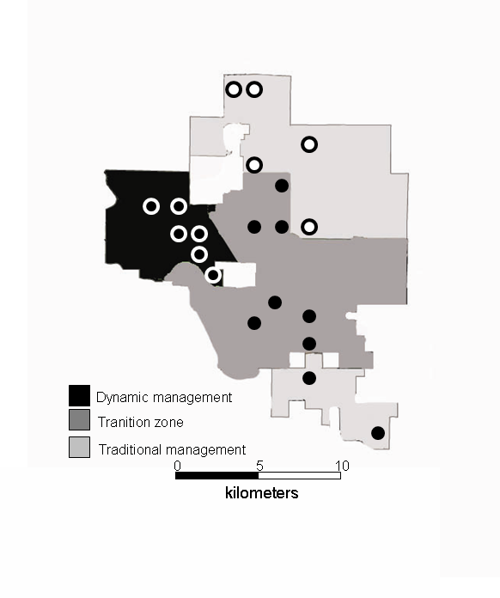
Figure 1. A rough map depicting the boundaries of the different management units as of 2004. Over the seven year study, the dynamic management was increased in area to fill the transition zone. The permanent plots used for this analysis are indicated by circles (continuous dynamic -black circles with white outlines, continuous traditional - white circles with black outline, other - black circles).
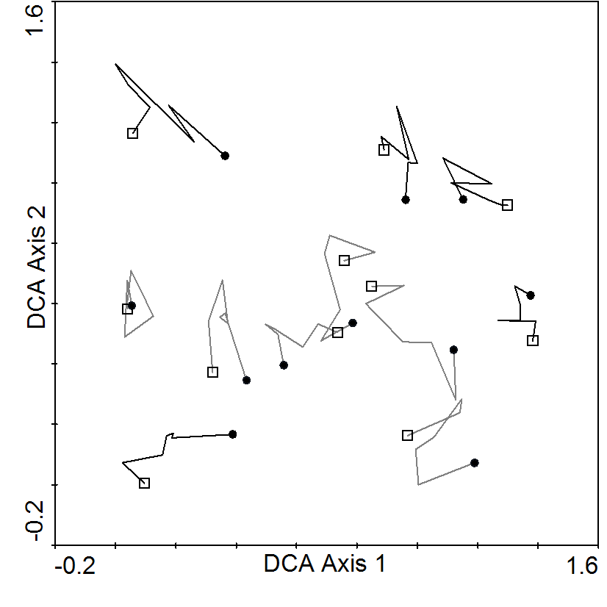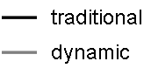
Figure 3. DCA scatter plot (eigenvalues 0.164 and 0.101; cumulative % variance of species data for both axes was 20.1 %) displaying the 13 quadrats from 1998 to 2004. The time series is indicated by a line segment (—) with joints at each year (black for traditional and grey for dynamic). The 1998 is illustrated by a circle (●) and the 2004 is illustrated by a square (□).
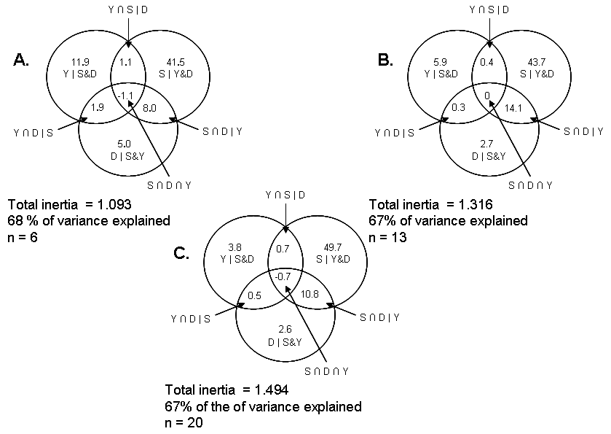
Figure 4. Variance partitioning for three subsets of the data: A. dynamic management only (n = 6), B. dynamic management and traditional management (n=13), and C. All plots regardless of management (n = 20). The values indicate the percent of interia explained by year (Y), site (S), and disturbance variables (D). The percent of interia was calculated by dividing the sum of all canonical eigenvalues by the total inertia and multiplying by 100.

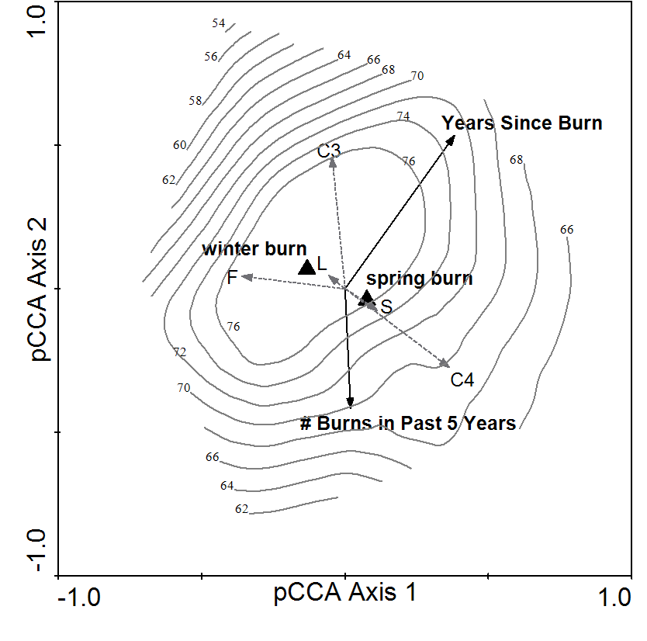
Management variables
Frequency of functional groups
▲
Species richness lowess countour
Figure 5. pCCA triplot of the disturbance regime given year and site as covariables. Passive variables which indicate the frequency of plant functional group in a site was also included. The explanatory variables in the model are indicated by black arrows and triangles, the passive variables are indicated by dotted gray arrows. The passive variables include: C3 = C3 grasses, C4 = C4 grasses, L = Legumes, F = Forbs, and S = Shrubs. The contour lines correspond to a lowess model fit to species richness.

